**Module-Wise Diagrams** for the **VeriHarvest Technical Architecture**

**High-Level System Architecture** – Shows the interaction between **AI, Blockchain, IoT, and Cloud Storage**.

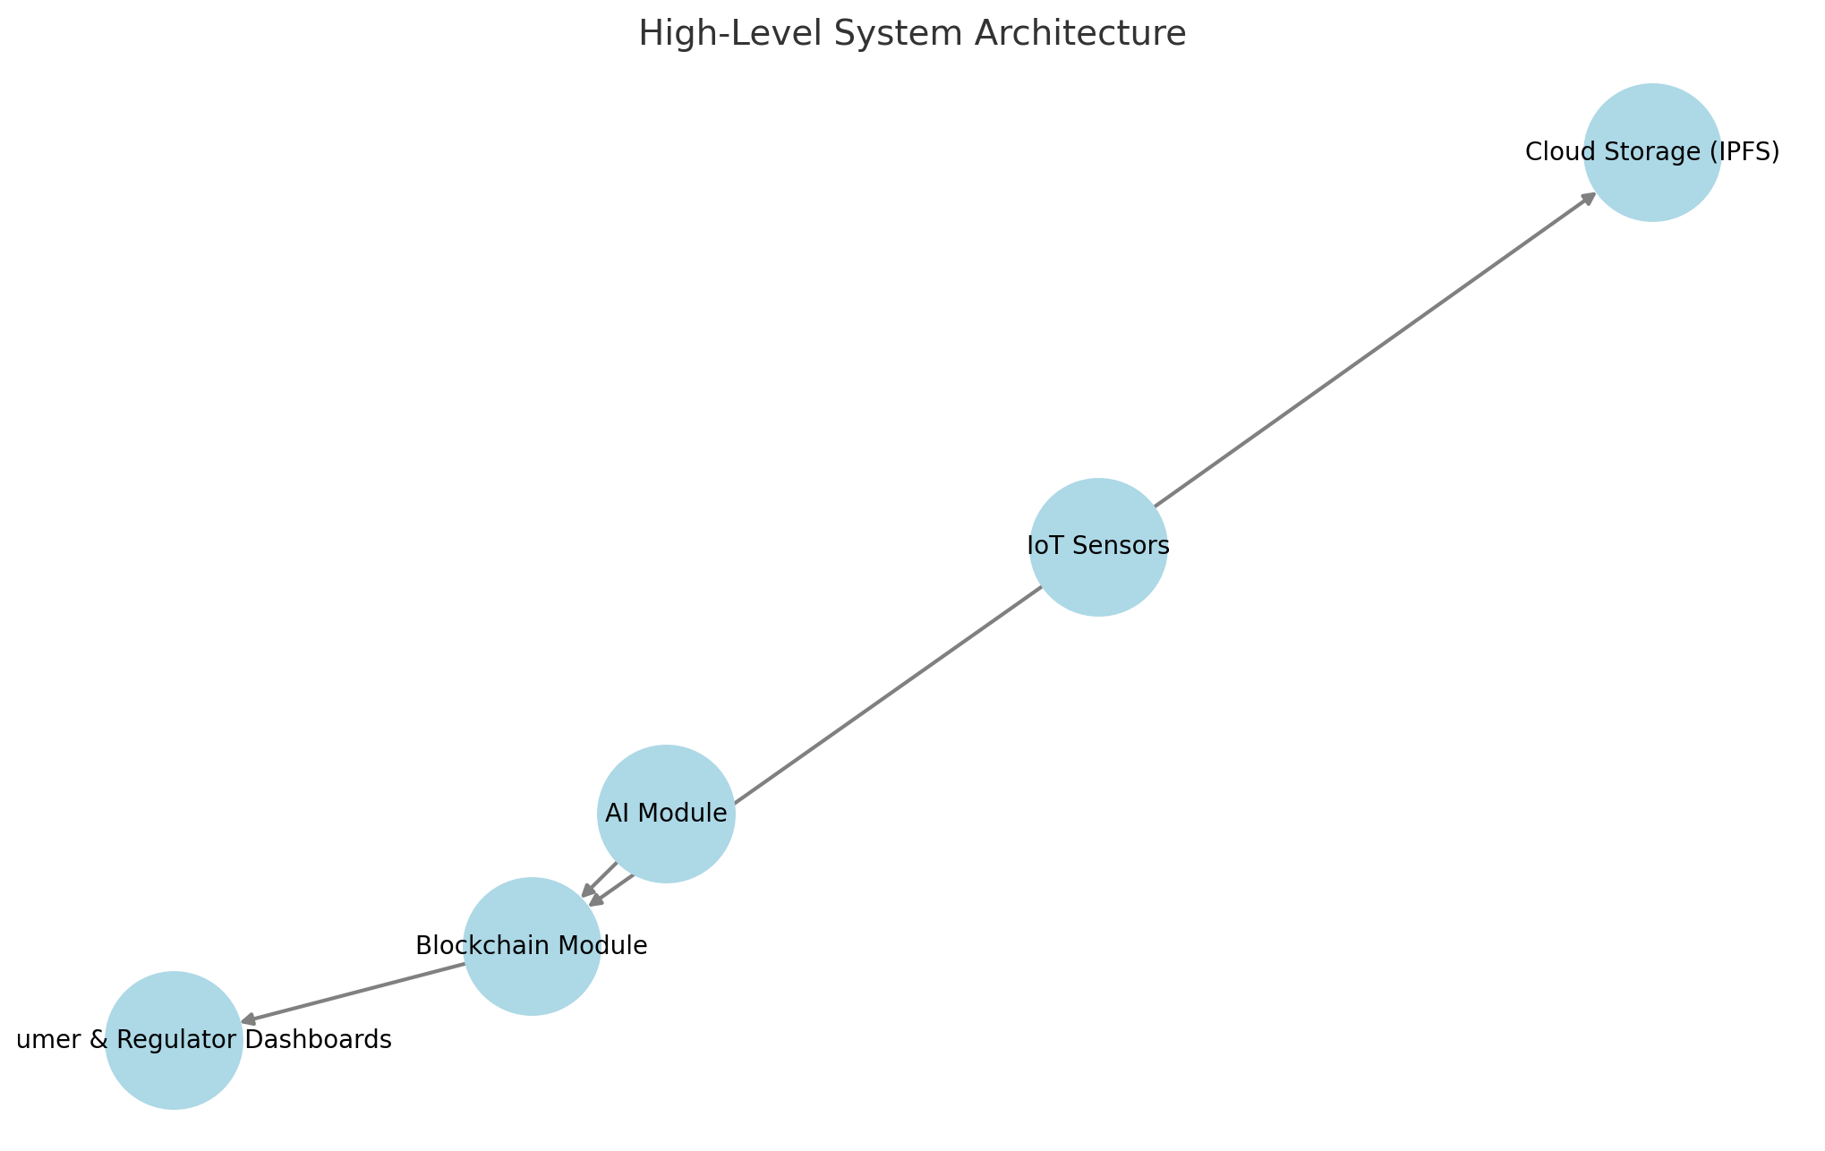

**AI-Based Food Fingerprinting** – Explains how food fingerprints are generated and stored **on-chain**.

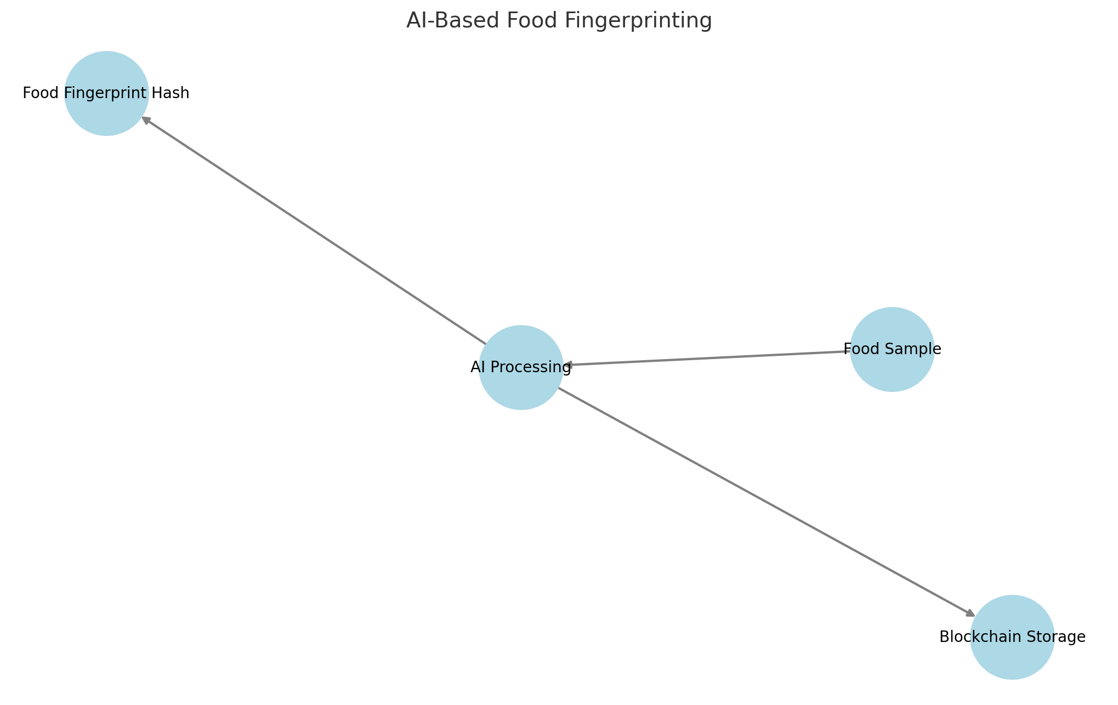

**IoT-Powered Real-Time Monitoring** – Displays the flow from **IoT sensors to Blockchain Alerts**.

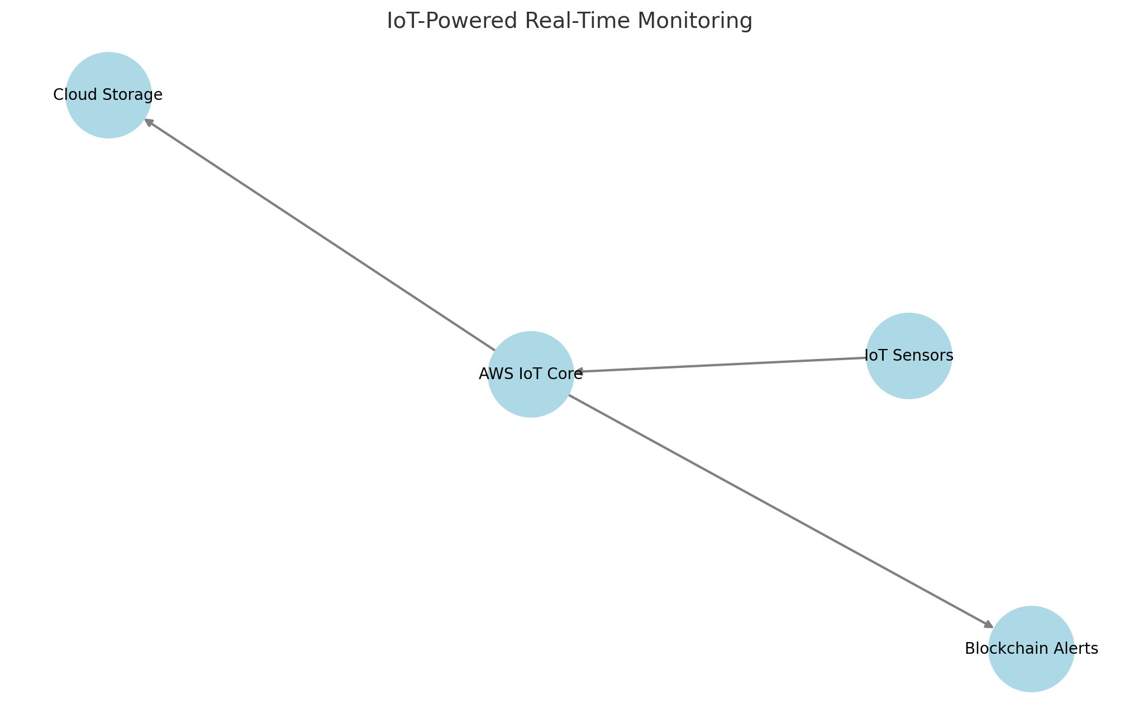

**Blockchain-Based Traceability** – Illustrates how **food authentication, trust scoring, and compliance alerts** work.

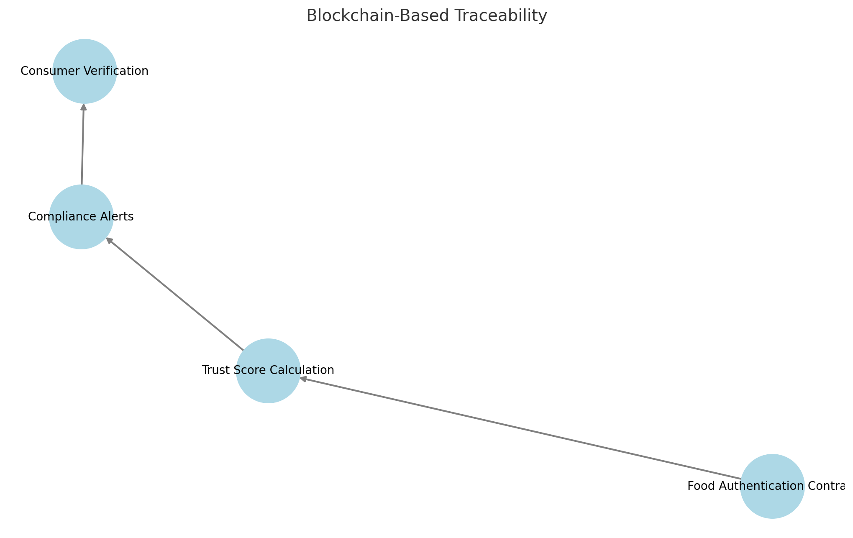

**User Interface Workflow** – Showcases how **Consumers, Regulators, and Suppliers** interact with the system.

